Austin Smothers

Professor Bustamante

CSC 137

June 10, 2019

Chapter 2 Homework



x=1, y=0, z=1 🡪 1.1 + 0.1 🡪 1 + 0 = **1**

x=1, y=1, z=0 🡪 1.0 + 1.0 🡪 0 + 0 = **0**



_c = active-low signal inverter therefore 0=on 1=off

_c=0, x=1 🡪 1.0 + 0.1 🡪 0 + 0 = **0**

_c=1, x=1 🡪 0.0 + 1.1 🡪 1 + 1 = **1**



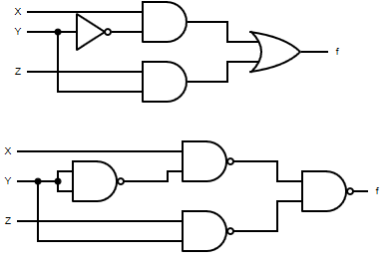



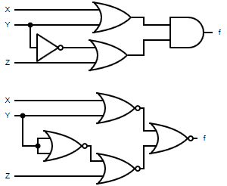



= y +

=

**POS of f = (x +)(y + z)**



= y +

dual of = (+ y)(+ )

**POS of f = (x +)(y + z)**

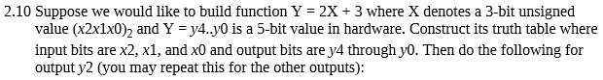

|  |  |  |  |  |  |  |  |
| --- | --- | --- | --- | --- | --- | --- | --- |
| x2 | x1 | x0 | y4 | y3 | y2 | y1 | y0 |
| 0 | 0 | 0 | 0 | 0 | 0 | 1 | 1 |
| 0 | 0 | 1 | 0 | 0 | 1 | 0 | 1 |
| 0 | 1 | 0 | 0 | 0 | 1 | 1 | 1 |
| 0 | 1 | 1 | 0 | 1 | 0 | 0 | 1 |
| 1 | 0 | 0 | 0 | 1 | 0 | 1 | 1 |
| 1 | 0 | 1 | 0 | 1 | 1 | 0 | 1 |
| 1 | 1 | 0 | 0 | 1 | 1 | 1 | 1 |
| 1 | 1 | 1 | 1 | 0 | 0 | 0 | 1 |



**y2 = x2x1 + x2x0 + x1 + x0**



**f(x1, x0) = ∑(2, 1)**



**y2 = x1 + x0**



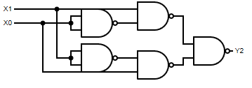



5 Transistors for minimal vs… upwards of 20 for canonical. Seems like minimal is a lot better





Canonical SOP: f = ( + y+ w+ wy) + (wx+ wxy)

(()( + y) + (w)(+ y)) + ((wx)(+ y))

(() + (w)) + (wx) 🡪 () + (wx)

**Minimal SOP: f = () + (wx)**Error! Bookmark not defined.



Canonical SOP: g = (bd +bcd + abd + abcd) + (bc+ abc)

((bd)(c +) + (abd) (c +)) + ((bc)(a +))

(bd) + (abd) + (bc) 🡪 (bd) + (bc)

**Minimal SOP: g = (bd) + (bc)**



Canonical SOP: h = ( + y+ w+ wy) + (wx+ wxy)

(()( + y) + (w)(+ y)) + ((wx)(+ y))

(() + (w)) + (wx) 🡪 () + (wx)

**Minimal SOP: h = () + (wx)**Error! Bookmark not defined.



Canonical SOP: t = (bd +bcd + abd + abcd) + (bc+ abc)

((bd)(c +) + (abd) (c +)) + ((bc)(a +))

(bd) + (abd) + (bc) 🡪 (bd) + (bc)

**Minimal SOP: t = (bd) + (bc)**



1. Minimal POS: **f = (w+y+z)(w++ z)()**
2. Minimal POS: **g = (a++d)()**
3. Minimal POS: **h = (w+y+z)(w++ z)()**
4. Minimal POS: **t = (a++d)()**